The Home Automation System

**A Project Report**

**Submitted by**

**Tanmay Toshniwal(21BCS7091)**

**Shashi Ranjan Mehta(21BCS7093)**

**Shivansh Singh(21BCS7026)**

**Shivam Kumar(21BCS7037)**

**Sonu Kumar(21BCS7019)**

***in partial fulfilment for the award of the degree of***

**Bachelor of Engineering**

**IN**

Computer Science



## Chandigarh University

March 2023

## 

## 

## BONAFIDE CERTIFICATE

Certified that this project report **“The Home automation system”** is the Bonafide work of **“Shashi Ranjan Mehta, Shivansh Singh, Tanmay Toshniwal, Shivam Kumar, Sonu kumar”** who carried out the project work under my/our supervision.

|  |  |
| --- | --- |
| **SIGNATURE**      **HEAD OF THE DEPARTMENT** | **SIGNATURE**        **SUPERVISOR** |

Submitted for the project viva-voce examination held on

**INTERNAL EXAMINER EXTERNAL EXAMINER**

|  |  |
| --- | --- |
|  |  |

**Abstract**

A home automation system is a technological advancement that enables homeowners to automate various home appliances and systems, allowing them to control and monitor them remotely through a smartphone or other connected device. This technology can improve energy efficiency, safety, and convenience in the home.

The proposed system consists of two main components; the first part is the server (web server), which presents system core that manages, controls, and monitors users’ home.

Servers is manged with the help of nodemcu esp8266 Users and system administrator can locally (LAN) or remotely (internet) manage and control system code. Second part is hardware interface module, which provides appropriate interface to user of home automation system

Overall, a home automation system can provide a high level of convenience, comfort, and security while reducing energy consumption and costs. As technology continues to advance, home automation systems are likely to become even more sophisticated and intuitive, making them an increasingly popular choice for homeowners seeking to improve their living spaces.

**CHAPTER 1**

**INTRODUCTION**

* 1. **Identification of Client/ Need/ Relevant Contemporary issue**

The need for an automated home system is to provide convenience, comfort, and security to homeowners or tenants. An automated home system can control and manage various household appliances such as lighting, heating, cooling, security systems, and entertainment systems. This technology can reduce energy consumption, save time and effort, and provide a more comfortable living environment.

One relevant contemporary issue related to an automated home system is privacy and security concerns. As these systems become more advanced and connected to the internet, they are vulnerable to cyber-attacks and hacking. The information collected by these systems, such as personal data, usage patterns, and habits, can also be at risk. Therefore, it is crucial to ensure that an automated home system has robust security measures in place to protect against cyber threats and privacy breaches. Additionally, ensuring that the system is up-to-date and regularly maintained can help mitigate the risks of security breaches.

* 1. **Identification of Problem**

One of the potential problems with an automated home system is its reliability. Automated home systems rely on multiple interconnected devices and software to work together seamlessly. If any of these components malfunction, it can affect the entire system and cause inconvenience to the homeowners. For example, if the lighting system fails to turn on or off, it can cause discomfort or even safety hazards. Similarly, if the security system fails to function correctly, it can compromise the safety of the occupants and their property.

Another problem that can arise with an automated home system is the complexity of the system. The more advanced the system, the more complex it becomes, and the more challenging it is to maintain and troubleshoot issues. If the system requires constant maintenance or repairs, it can cause frustration to the homeowners and lead to additional expenses.

Lastly, the cost of an automated home system can be a problem for some homeowners. The installation and maintenance of an automated home system can be expensive, and it may not be feasible for everyone to afford it. Additionally, the cost of repairing or upgrading the system can be significant, especially if it requires specialized expertise.

Overall, while automated home systems offer many benefits, they can also present potential problems related to reliability, complexity, and cost.

* 1. **Identification of Tasks-**

The overview of the hardware ,software and technology we are using in this project-

**1.3.1 Hardware specification-**

**1.NodeMCU (esp8266)**- NodeMCU is an open-source development board based on the ESP8266 Wi-Fi module. The ESP8266 is a low-cost Wi-Fi chip with full TCP/IP stack and microcontroller capabilities. NodeMCU provides an easy-to-use firmware for programming the ESP8266 chip. It allows developers to write Lua scripts or use the Arduino IDE to program the board.

Some features of NodeMCU include:

* Wi-Fi connectivity: NodeMCU can connect to Wi-Fi networks and act as a Wi-Fi access point.
* GPIO pins: NodeMCU has a number of general-purpose input/output (GPIO) pins that can be used for a variety of purposes.
* Analog input: NodeMCU has an analog-to-digital converter (ADC) that can be used to read analog sensors.
* USB interface: NodeMCU can be programmed and powered through a USB interface.

NodeMCU is widely used for IoT projects, such as home automation, sensor networks, and robotics. It is a low-cost and versatile platform for prototyping and experimenting with connected devices.

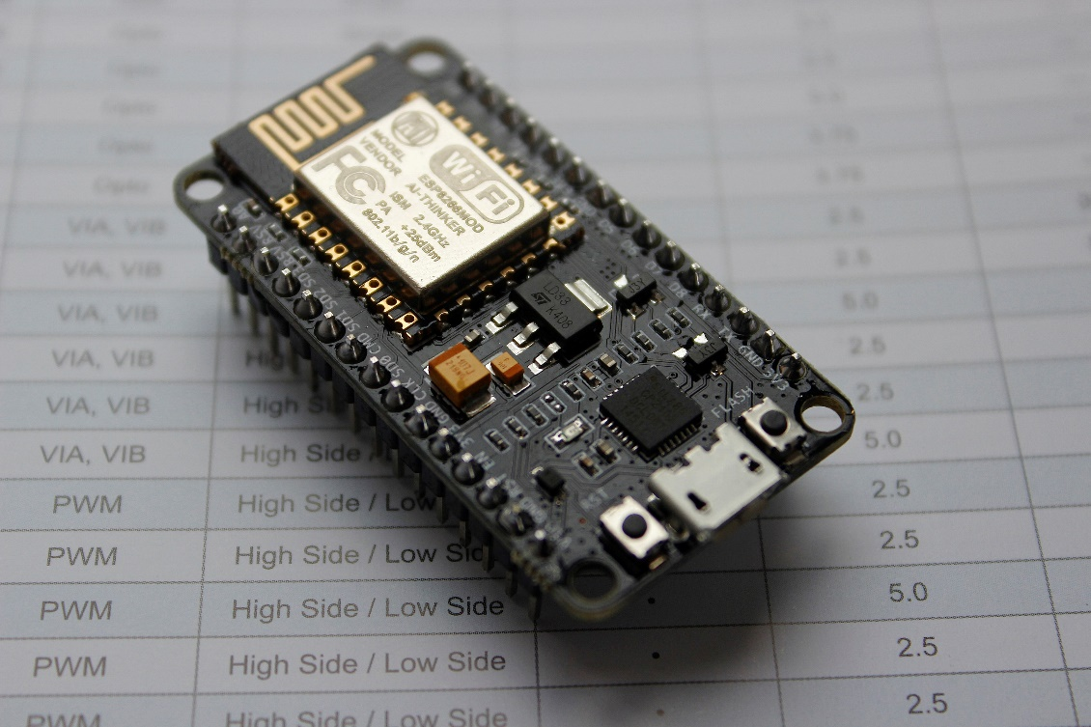

Fig 1.1(nodeMCU)

**2. 5 volt 4 channel relay-**A 5V 4-channel relay is an electronic module that allows you to control up to 4 high-power devices using a microcontroller or other low-power signal source. Each channel of the relay consists of an electromechanical switch that can be activated by applying a small voltage to its control input.

When the control voltage is applied, the relay switches its contacts, allowing a separate circuit to be connected or disconnected from the main power source. This makes relays useful for controlling high-power devices such as motors, lights, or heaters, using low-power control signals from microcontrollers, sensors, or other electronic devices.

The 5V 4-channel relay module typically includes input and output pins for each channel, as well as a common ground and power supply input. The control signals for each channel are typically provided by separate digital output pins of a microcontroller or other control device, while the high-power devices are connected to the relay's output terminals.

It is important to note that when using relays to control high-power devices, appropriate safety measures must be taken to prevent electrical shock, fire, or other hazards. This may include the use of fuses, circuit breakers, or other protective devices, as well as proper grounding and insulation of all components.

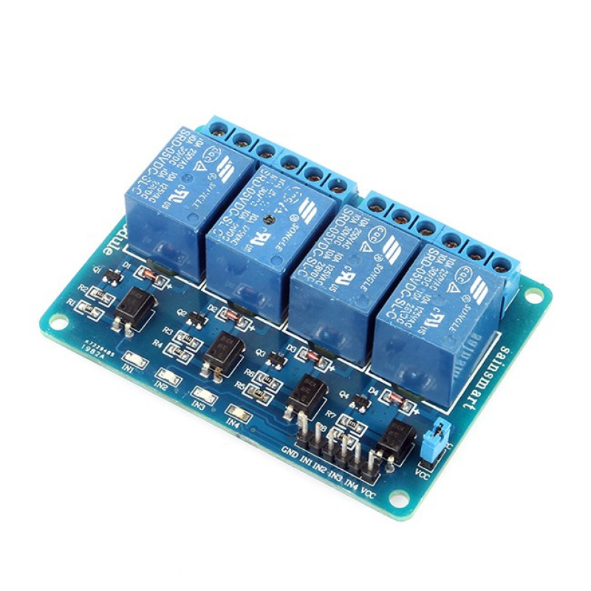

Fig 1.2(relay)

**3. Breadboard –**A breadboard is a tool used for building and testing electronic circuits without the need for soldering. It consists of a plastic board with a grid of holes arranged in rows and columns. Each hole contains a metal contact, and the contacts in each row and column are connected electrically.

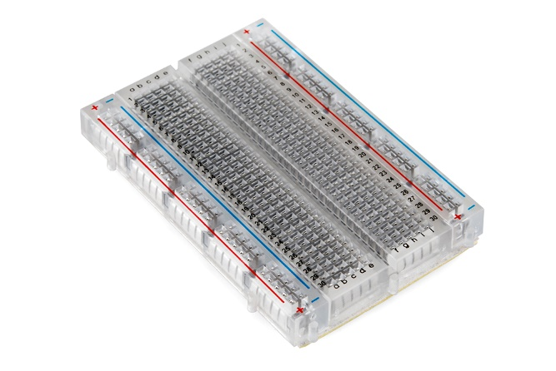

Fig 1.3(Breadboard)

**4.LED –** LED stands for Light Emitting Diode. It is a semiconductor device that emits light when an electric current passes through it. LEDs are highly efficient at converting electrical energy into light and are therefore used in a wide variety of applications, such as lighting, displays, and electronic devices.

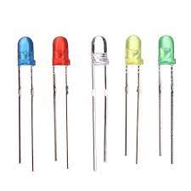

Fig 1.4(LED)

**1.3.2 Software specification-**

**Arduino IDE -** Arduino IDE is an Integrated Development Environment (IDE) designed to program Arduino boards. It is a software application that runs on a computer and allows users to write, compile, and upload code to Arduino boards. The Arduino IDE is open-source and freely available for download from the Arduino website.

The Arduino IDE comes with a vast library of pre-written code called sketches that help developers get started quickly. It also supports third-party libraries that can be downloaded and added to the IDE.

One of the key features of the Arduino IDE is the ability to upload code to the Arduino board via a USB connection. The IDE automatically detects the board and its communication port, making it easy to upload code and debug the application.

Overall, the Arduino IDE is an essential tool for anyone interested in developing projects with Arduino boards. It provides a streamlined and user-friendly interface that simplifies the process of programming and uploading code to Arduino boards.

**Blynk -** The Blynk website is a platform for building mobile and web applications for the Internet of Things (IoT). It provides a range of tools and resources for developers to create and manage projects that integrate with a wide range of hardware and software platforms.

On the Blynk website, you can learn about the Blynk platform and its features, download the Blynk app for iOS or Android, sign up for a Blynk account, and access documentation, tutorials, and support resources.

**Android Studio -** Android Studio is an integrated development environment (IDE) for creating Android applications.Android Studio also includes support for the latest Android SDKs, allowing developers to easily target a wide range of Android devices with their apps. It supports multiple programming languages, including Java and Kotlin, and offers a range of features to simplify the development process, such as code templates, auto-complete, and real-time error checking.

Some of the key features of Android Studio include:

* Visual layout editor: Allows developers to create and modify the user interface of their apps using a drag-and-drop interface.
* Code editor: Provides a powerful and customizable code editor that supports a range of programming languages.
* Emulator: Allows developers to test their apps on a virtual device that mimics the behavior of a real Android device.
* Performance profiler: Helps developers identify performance bottlenecks in their apps by providing detailed insights into CPU usage, memory usage, and network activity.
* Gradle build system: Provides a flexible and efficient build system for Android apps, allowing developers to easily manage dependencies and build variants.

Overall, Android Studio is a powerful and comprehensive IDE that is essential for anyone looking to develop Android applications.

**GitHub -** GitHub is a web-based platform that provides hosting for software development version control using Git. It allows developers to collaborate on code with others and provides tools for version control, bug tracking, and project management.

**Gannt chart-**

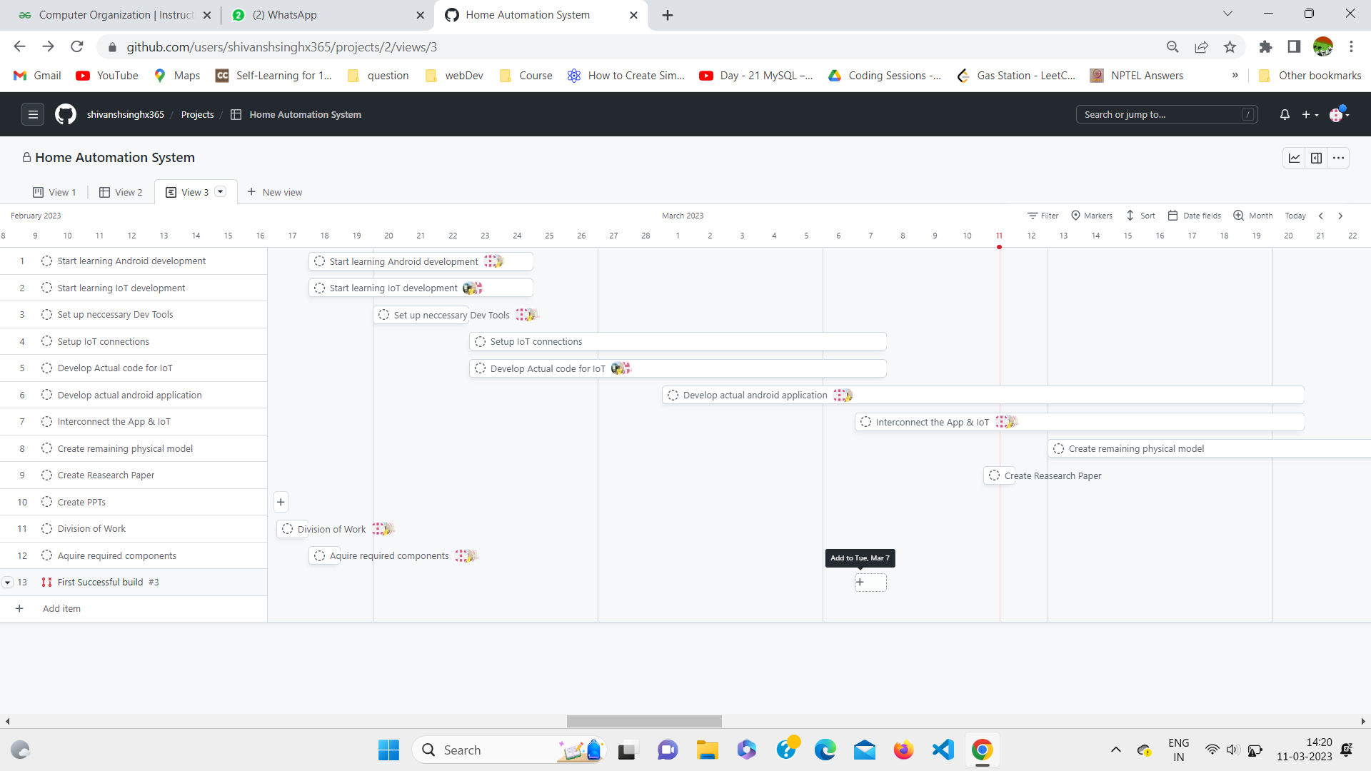

The project is divided into 3 main phases-

**IOT Phase-** This phase is concerned with setting up the basic IoT systems and making primary electronic connections to get to a working stage, and provide the basic switching functionality via the NodeMCU webserver and a basic web interface. This will serve as a base for all further development.

**Application Phase-** This is the second phase of the development which deals with creation of an android application to interface with our hardware over the internet. The app aims to provide more functionality over the basic web interface developed in phase 1. These functionalities include ability to control devices via Google Assistant and developing a native app instead of a locally hosted website.

**Integration Phase-** This is the final phase of the project that deals with interconnecting the application with the hardware and also completing the remaining electronic circuits in order to provide a fully functional and complete home automation system.